**Steps for running project:**

**Activating the virtual environment:**



Virtual environment: (venv1) F:\learning\LLM_neo4j_rag_app\chatbot_api>.\chatbot_api\chatbot_api_venv\Scripts\avtivate

OR



(venv1) F:\learning\LLM_neo4j_rag_app\chatbot_api>F:\learning\LLM_neo4j_rag_app\venv1\Scripts\activate.bat

**Neo4j Instance creating & running:**

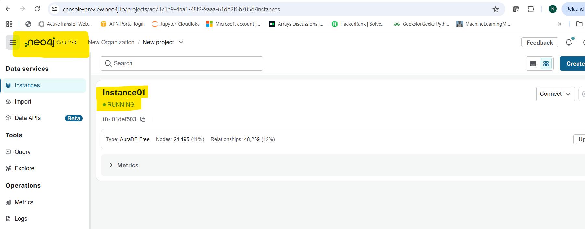

Download the config file of the running instance (in case new instance is created) and update the details in the config file as below:

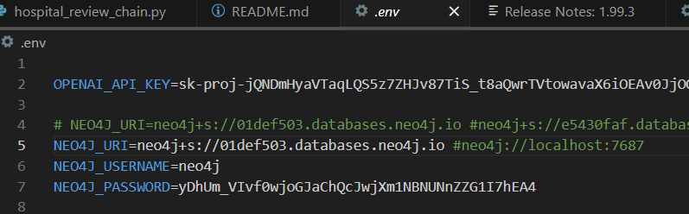

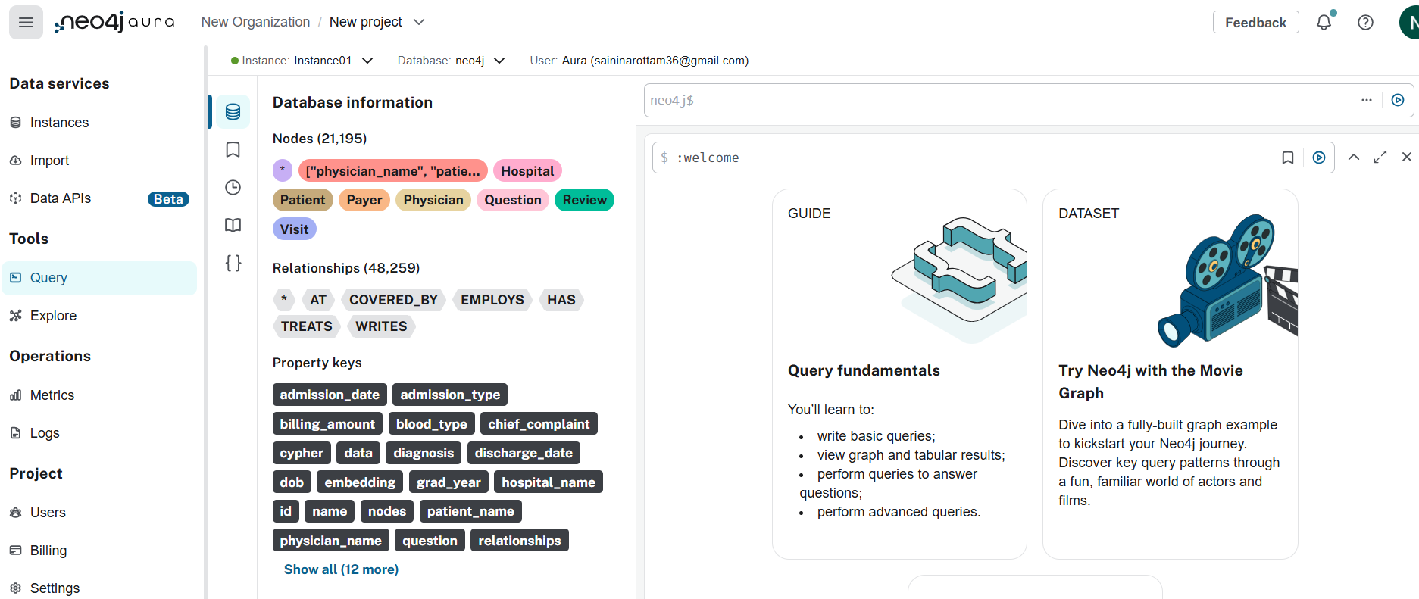

**Docker Desktop running instance:**

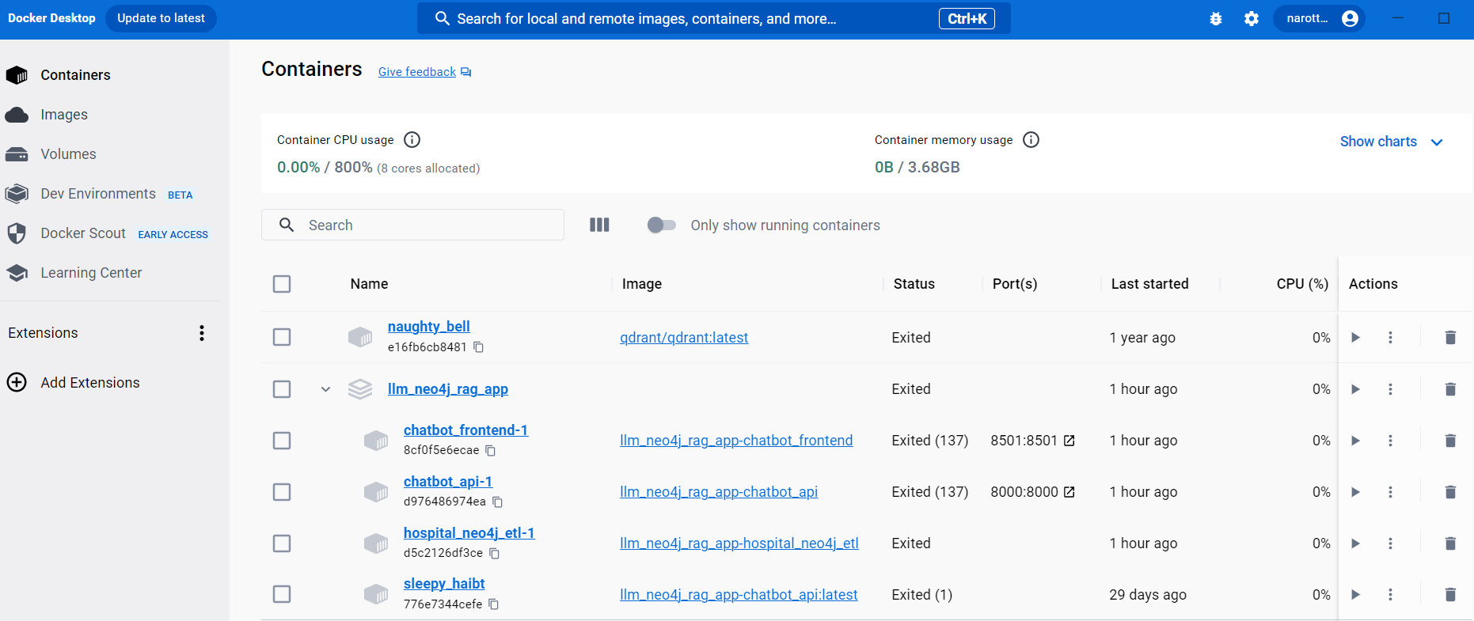

**Creating a docker build image:**



docker-compose up –build

**### Once all the above steps are done, then navigate to below link and query the Neo4j DB**

